1 NORTH |  | 9:15 Calendar Update    10:00 Java Music Club (Neely)  2:30 BINGO (Neely)  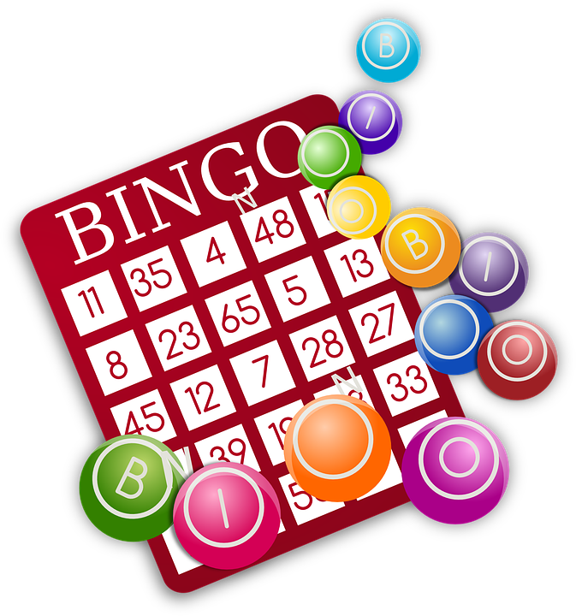 |  | 10:30 Virtual Reality (Neely)  10:45 Aromatherapy and Relaxation (AR)  2:30 Wiener DogDice Race (AR)  3:00 Words Game (AR)  6:30 September Word Game (Neely) | 10:30 BINGO (Neely)    2:30 Blessed Frederic Ozanan Catholic Mass (Neely) | 1:00 Snoezelen with Northern Lights (AR)  1:30 Reading Together (AR)  2:30 Ball Toss (AR)  6:30 Songs of Joy and Togetherness (Neely) | 10:00 Music Mornings (AR)  10:30 Woodworking Club (Neely)  2:30 Active Together (Neely)  3:00 Sound Therapy (Neely) | 10:30 Word Game (Neely)  2:30 Balloon Toss (AR)  3:15 1:1 Friendly Visits (RR)
10:30 Music with Curtis (1N)  10:30 Breathing Exercises (Neely)  11:00 Finger Painting (Neely)    2:30 Piano Recital (Neely) | 10:30 BOOKCLUB: Backyard Stories with Ann (Neely)  2:30 BINGO (Neely) |  | 10:30 Stretch and Flex Time (AR)  10:45 Ball-Toss Fun (AR)  2:30 Java Time Club (Neely)    6:30 Creative Games (Neely) |  | 10:30 BINGO (Neely)  2:30 Montessori Time (RR)  3:15 Hand Coloring (AR) | 1:30 Ballon Fun (AR)  2:30 Ice Cream Visits & Comedy (TV-RR)  3:15 Word Category (Neely)  6:30 Comedy Night (Neely) | 10:30 Strolling Time (Indoor/Outdoor)  11:15 Seated Exercise (AR)  2:30 Toss Your Hat in the Ring (AR)  3:00 Snoezelen with the Northern Lights (AR) | 10:30 Words in Word (Neely)  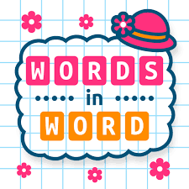  2:30 Group Exercise (AR)  3:00 Balloon Toss (AR)
10:30 Hymn Sing with Carol (Neely)  2:30 Reading Together (AR)  3:00 Table Games (AR) | 10:30 Gentle Stretch (AR)  10:30 Aroma Therapy & Hand Massage (AR)  2:30 BINGO (Neely) |  | 10:00 Java Music Club (Neely)  2:30 Department Meeting  6:30 Therapeutic Sounds Session with Santta (Neely) |  | 10:30 Entertainment with Emilio (Neely)  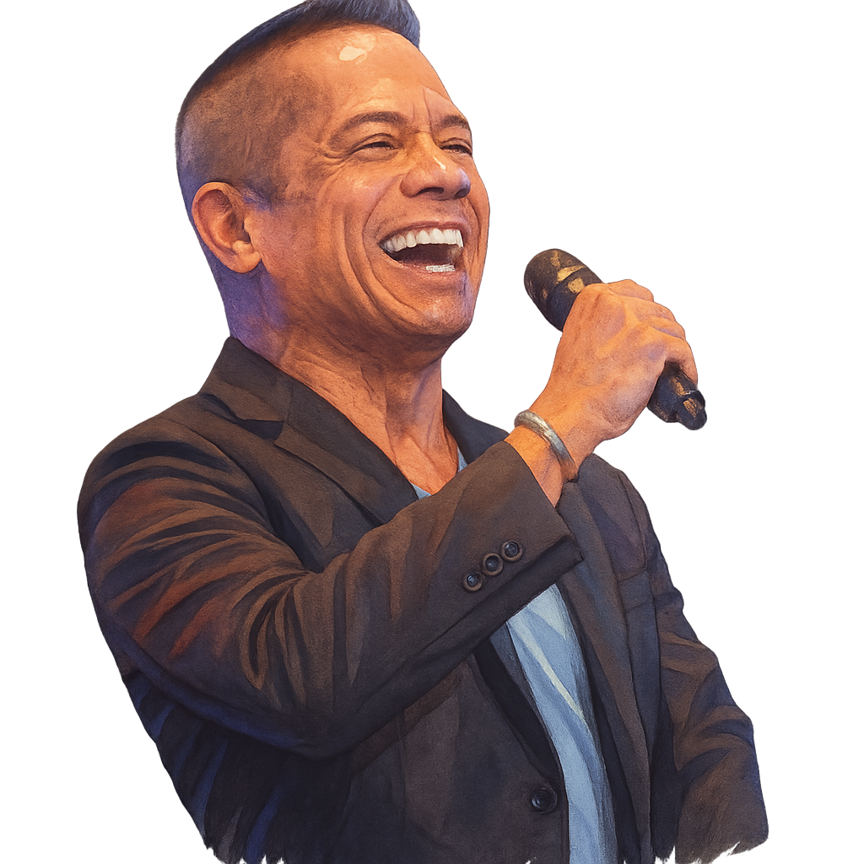  2:30 BINGO (Neely) | 1:00 Clean & Sweep (AR)  1:30 Reading Together (AR)  2:30 Parachute Fun (Neely)  6:30 Thankful Tree Craft (Neely) | 2:30 Piano Hymn Sing with Priscilla (Neely)  2:30 The Colombrew Bakery Cart (RR)   | 10:30 Word Game (Neely)  2:30 Galaxy Corner with Aroma Therapy and Breathing Exercises (AR)
10:30 1:1 Friendly Visit (RR)  10:45 Inddor/Outdoor Stroll**  2:30 Manicure and Comedy Time (AR) | 10:30 BOOKCLUB: Backyard Stories with Ann (Neely)  2:30 Java Time Club (Neely)  2:45 Aromatherapy (TV) |  | 10:30 Food Committee & Resident Council (Neely)  10:15 Pet Therapy with Lola  2:30 Breathing Exercise (AR  6:30 Wine and Cheese with Curtis (Neely) |  | Outing  9:30 a.m. – 2:00 p.m.  Varley Art Gallery of Markham  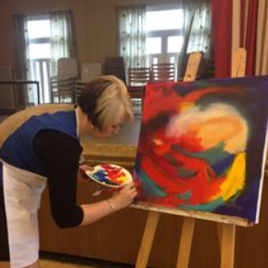  2:30 Bible Study with Captain Farr (Neely) | 1:00 Roll & Race (AR)    2:30 Markhaven Seniors Awards (Neely)  6:30 Unscramble the Words (Neely) | 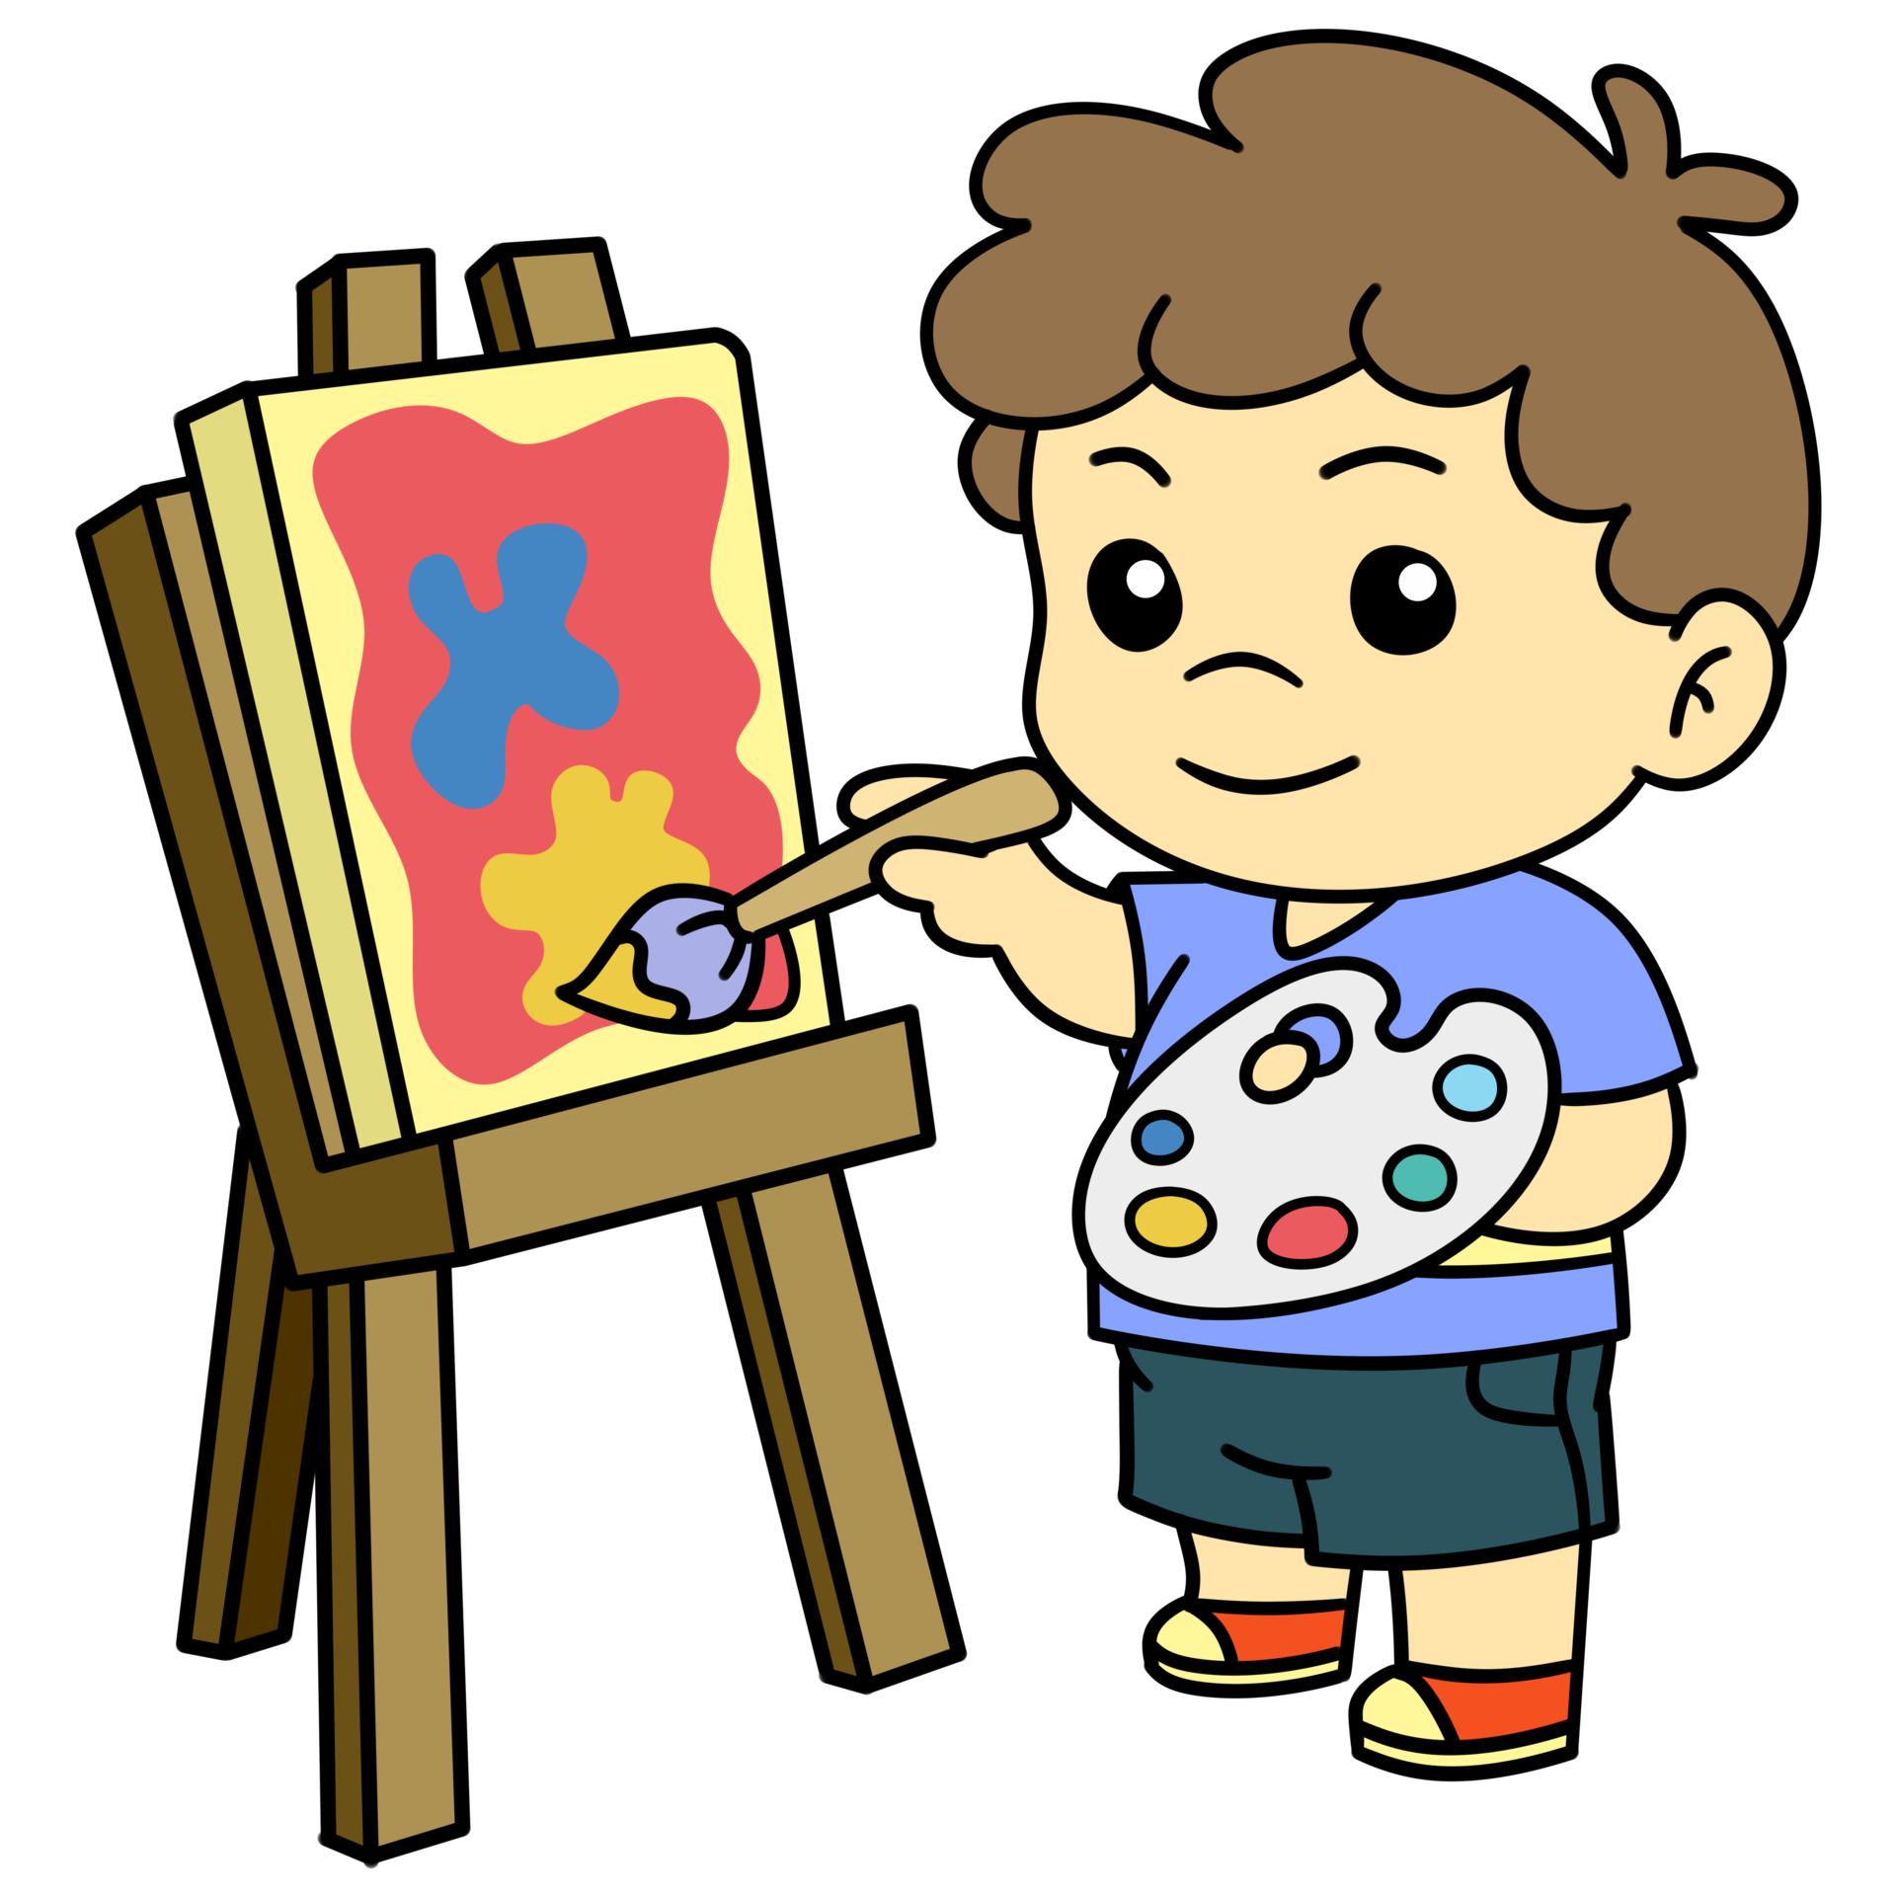  10:00 Young at Heart Painting (Neely)    2:30 Movie Matinee  PAUL BLART:  Mail Cop 1.  (Neely) | 10:30 Words in Word (Neely)  2:30 Group Exercise with Santta (AR)  3:00 Coloring Group (AR)
10:30 Hymn Sing with Carol (Neely)  2:30 Birthday Bash with    Rosita Stone (Neely) | 10:30 Gentle Exercises (AR)  11:00 Volley Balloons (AR)  2:30 BINGO (Neely) |  | 10:30 Communion (Neely)    12:00 Diner’s Club: The Toston Colombian Cuisine  2:45 Arts and Crafts (Neely)    6:30 Table Games (Neely) |  | PARKWAY

Recreation Staff: Gene & Santta Legend: Neely Auditorium (Neely) Activity Room (AR) Television Room (TV) Sun Room (SR) Resident Room (RR) Balcony (BA)
Sunday | Monday | Tuesday | Wednesday | Thursday | Friday | Saturday
 | 1  Labor Day | 2 | 3 | 4 | 5 | 6
7  Grandparents Day | 8 | 9 | 10 | 11 | 12 | 13
14 | 15 | 16 | 17 | 18 | 19 | 20  Oktoberfest Begins
21 | 22  Rosh Hashanah Begins  Autumn Begins | 23 | 24 | 25 | 26 | 27
28 | 29 | 30

sssssssssss

