1 SOUTH |  | 9:15 Calendar Visit (RR)    10:00 Java Music Club (Neely)  2:30 BINGO (Neely)  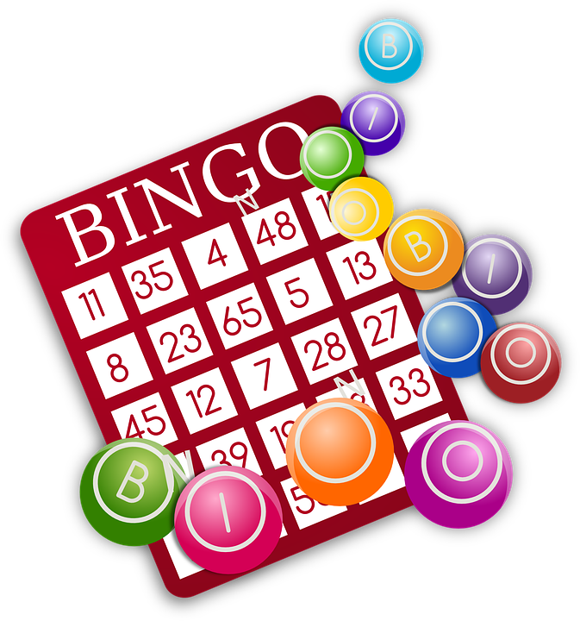 |  | 10:30 Virtual Reality (Neely)  11:00 Pet Therapy with Lola (RR)  2:30 Wiener Dog Dice Race (AR)  6:30 September Word Game (Neely) | 10:30 BINGO (Neely)    2:30 Blessed Frederic Ozanam Catholic Mass (Neely) | 1:00 Daily Bread Reading (RR)  2:30 Bean Bag Toss (AR)  3:00 Coloring Club (AR)  6:30 Songs of Joy and Togetherness (Neely) | 10:00 Music Mornings (AR)  10:30 Woodworking Club (Neely)  2:30 Active Together (Neely)  3:00 Sound Therapy (Neely) | 10:30 Word Game (Neely)  2:30 Ball Toss (AR)  3:00 Aromatherapy and Warm Hands Massage (AR)
  10:30 Catholic Mass Streaming (AR-TV)  10:45 1:1 Spiritual Reading (RR)  2:30 Piano Recital (Neely) | 10:30 BOOKCLUB: Backyard Stories with Ann (Neely)  2:30 BINGO (Neely) |  | 10:30 Exercise Time (AR)  11:00 Pet therapy With Lola  2:30 Java Time Club (Neely)    6:30 Creative Games (Neely) |  | 10:30 BINGO (Neely)  2:30 Tea Social and Fall Trivia Time (AR)  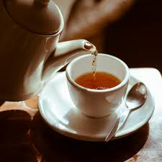 | 1:00 Strolling Time (Outdoor)  1:30 1:1 Activities (RR)  2:30 Ball Toss (AR)  6:30 Comedy Night (Neely) | 10:15 Virtual Reality (AR)  11:00 Indoor Strolls (Hallway)  2:30 Toss Your Hat in the Ring (AR)  3:00 Snoezelen with the Northern Lights (AR) | 10:30 Words in Word (Neely)  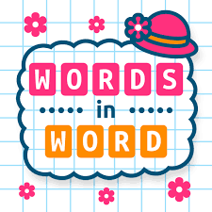  2:30 Basketball Playing (AR)  3:30 Adding Colors with Water (AR)
10:30 Hymn Sing with Carol (Neely)  2:30 Sunday Jazz and Toss the Ball (AR)  3:00 Outdoor Strolling (Outdoor) | 10:30 Gentle Stretch and Relaxation Music (AR)  11:00 Let’s Play with the Words (AR)  2:30 BINGO (Neely) |  | 10:00 Java Music Club (Neely)  2:30 Department Meeting  6:30 Therapeutic Sounds Session with Santta (Neely) |  | 10:30 Entertainment  with Emilio (Neely)  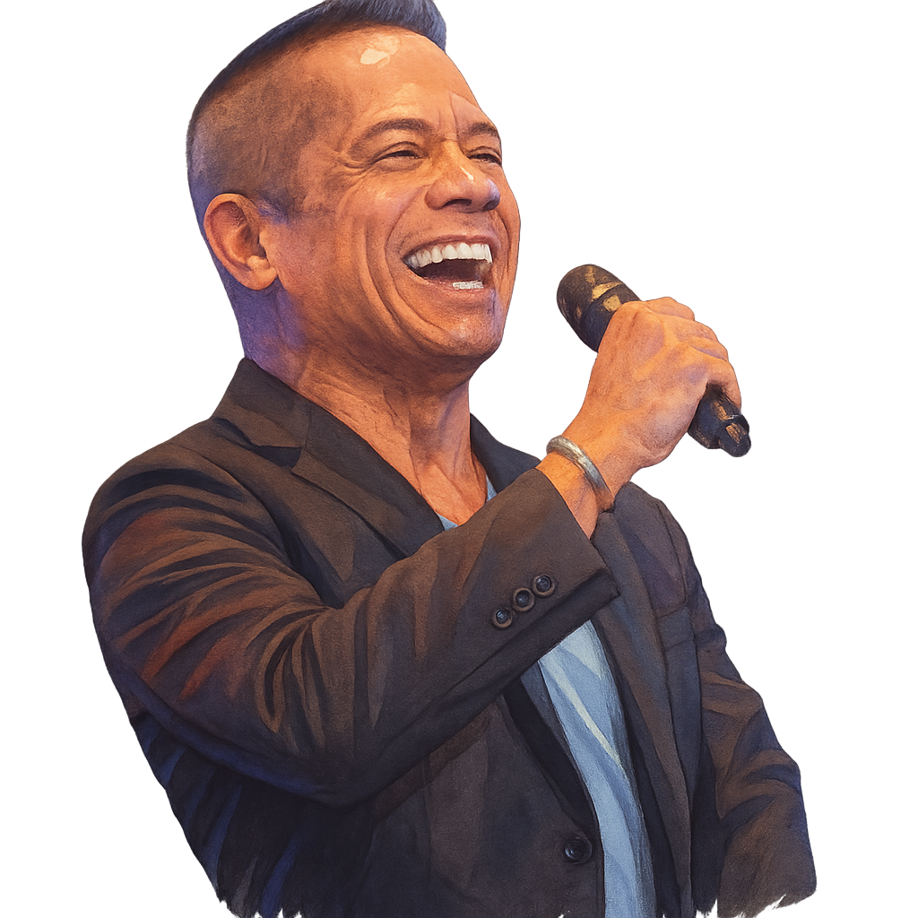  2:30 BINGO (Neely) | 1:00 Reading Time (AR)  1:30 1:1 Visits (RR)  2:30 Parachute Fun (Neely)  6:30 Thankful Tree Craft (Neely) | 10:30 Piano Hymn Sing with Priscilla (Neely)  2:30 The Colombrew Bakery Cart (RR)   | 10:30 Word Game (Neely)  2:30 Aromatherapy and Fun with Lucy (AR)  2:45 Bowling (AR)
10:30 Catholic Mass Streaming (AR-TV)  10:45 Manicure (RR)  2:30 Gazebo Gathering (Outdoor)  3:00 Movie Time (TV) | 10:30 BOOKCLUB: Backyard Stories with Ann (Neely)  2:30 Java Time Club (Neely) |  | 10:30 Food Committee & Resident Council (Neely)  11:00 1:1 Activities (RR)  2:30 Ring Toss (AR)  6:30 Wine and Cheese with Curtis (Neely) |  | Outing  9:30 a.m. – 2:00 p.m.  Varley Art Gallery of Markham  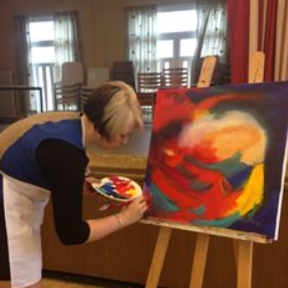  2:30 Bible Study with Captain Farr (Neely) | 1:00 Roll & Race (AR)    2:30 Markhaven Seniors Awards (Neely)  6:30 Unscramble the Words (Neely) | 10:00 Young at Heart Painting (Neely)  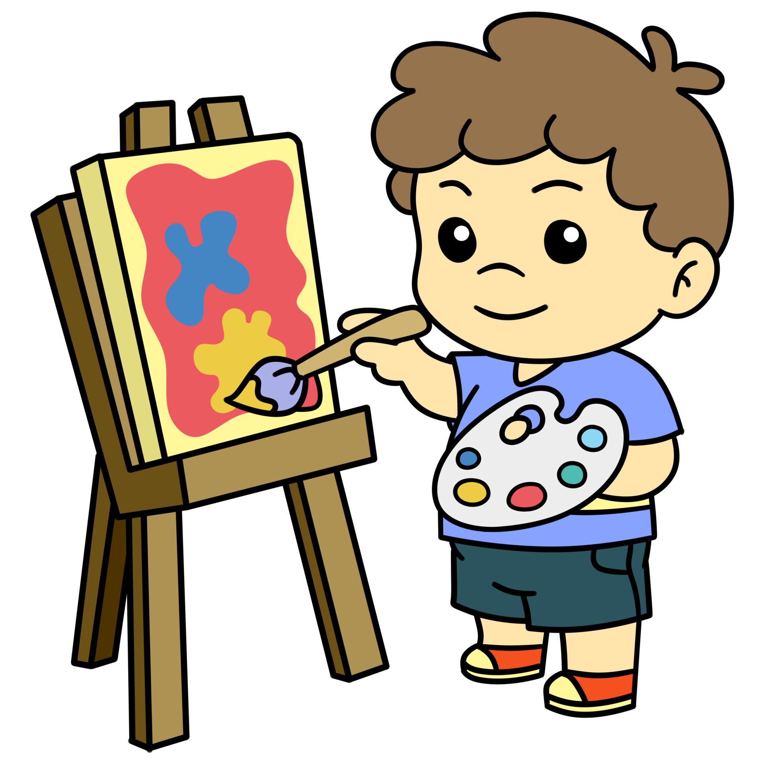    2:30 Movie Matinee-  PAUL BLART:  Mail Cop 1.  (Neely) | 10:30 Words in Word (Neely)  2:30 Physical Games (AR)  3:15 Indoor Strolling (Hallway)
10:30 Hymn Sing with Carol (Neely)  2:30 Birthday Bash with  Rosita Stone (Neely)   | 10:30 Exercise Club (AR)  11:00 Word Games (AR)  2:30 BINGO (Neely) |  | 10:30 Communion (Neely)  12:00 Diner’s Club: The Toston Colombian Cuisine      2:45 Expressive Arts and Crafts (Neely)  6:30 |  | PARAMOUNT

Recreation Staff: Sukhpreet Legend: Neely Auditorium (Neely) Activity Room (AR) Television Room (TV) Sun Room (SR) Resident Room (RR)
Sunday | Monday | Tuesday | Wednesday | Thursday | Friday | Saturday
 | 1  Labor Day | 2 | 3 | 4 | 5 | 6
7  Grandparents Day | 8 | 9 | 10 | 11 | 12 | 13
14 | 15 | 16 | 17 | 18 | 19 | 20  Oktoberfest Begins
21 | 22  Rosh Hashanah Begins  Autumn Begins | 23 | 24 | 25 | 26 | 27
28 | 29 | 30

sssssssssss

